Medisure Analysis
Time stamp: 12:44 pm
Analyst: Chinonso Eneje

Findings:

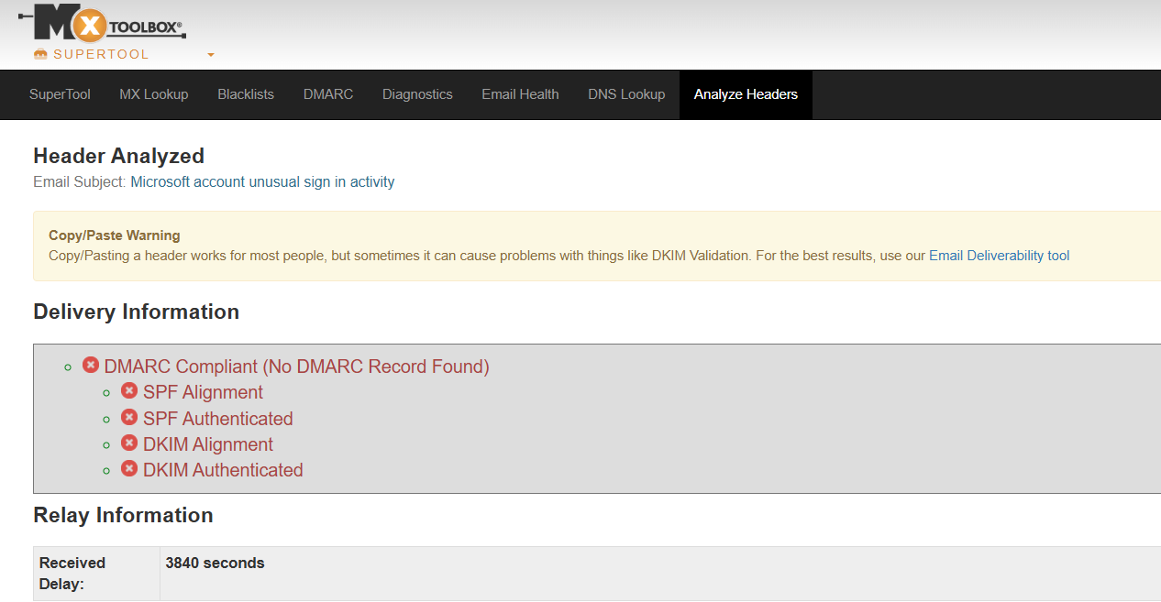
Figure1: image showing delivery information
From Figure1, the delivery information indicates that no DMARC record was found, the email failed SPF alignment and authentication, it also failed DKIM alignment and authentication. It also took 3840 seconds before email could be received. These are abnormal circumstances, ideally emails are received in just few seconds and legitimate emails pass SPF & DKIM alignment and authentication .
IOC
Originating IP address: 89.144.44.41
Mail: mail.access-accsecurity.com
Reply to: solutionteamrecognizd03@gmail.com
Date: Wed, 16 Aug 2023 00:15:00 +0100

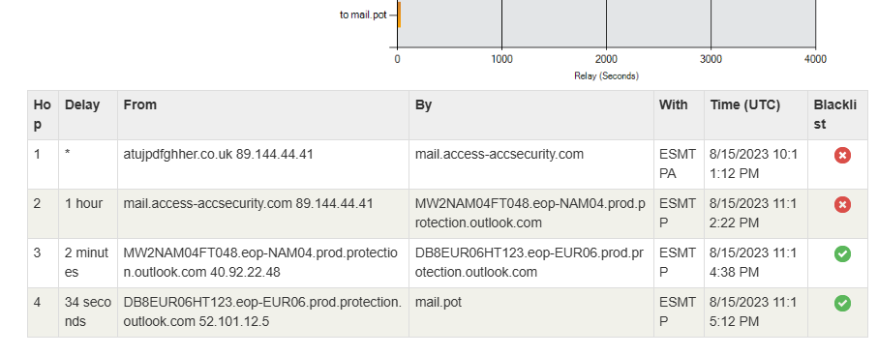Figure2 : Image showing the HOP information and originating IP address
Figure2 shows that this email has passed through 4 email servers before getting to us, the sending email IP address(89.144.44.41, mail.access-accesssecurity.com) does not originate from a Microsoft account, this email is also show to have been blacklisted. These indicators shows that this email is likely to be malicious.

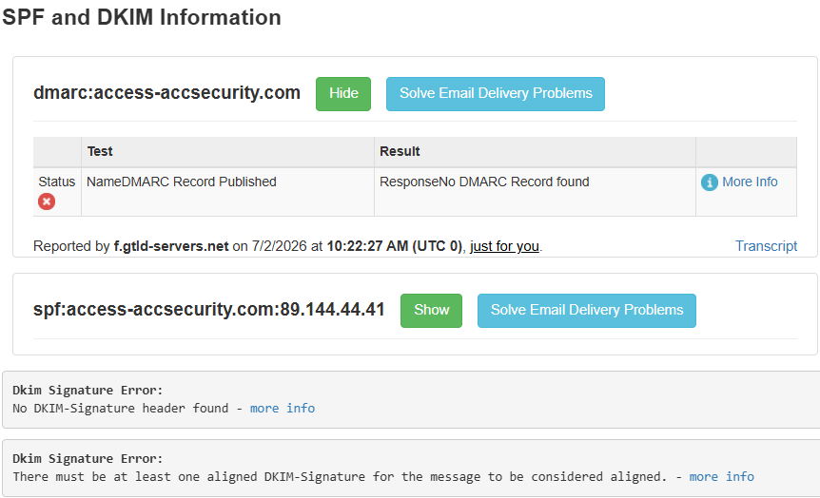Figure3 : Image showing SPF and DKIM information
Figure 3 shows that no DMARK record was published, this entails that DMARK could not provide instructions to the server on how to handle the email when it fails SPF or DKIM. The domain of access-accesssecurity .com does not designate the IP address 89.144.44.41 as permitted senser.

URL and Attachment Analysis
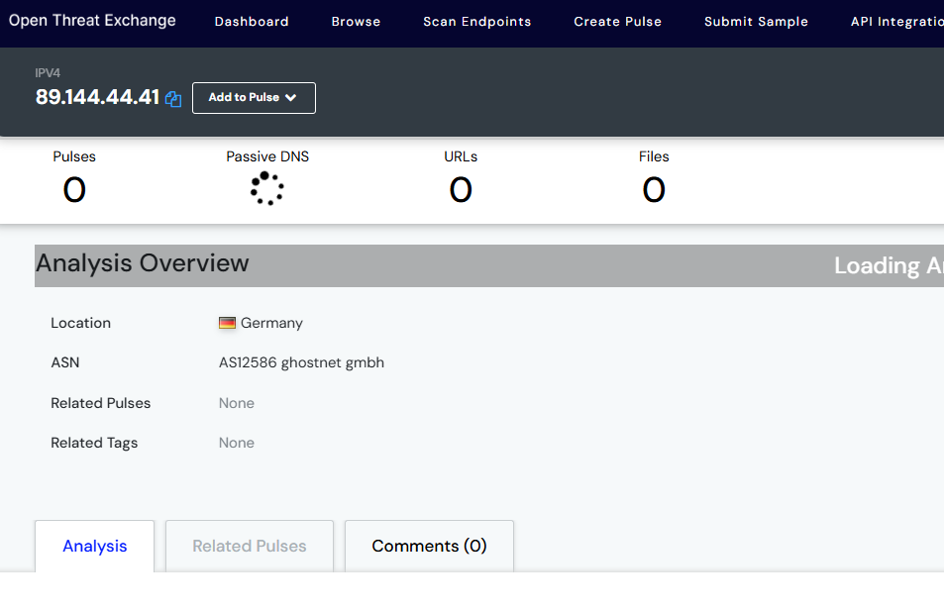
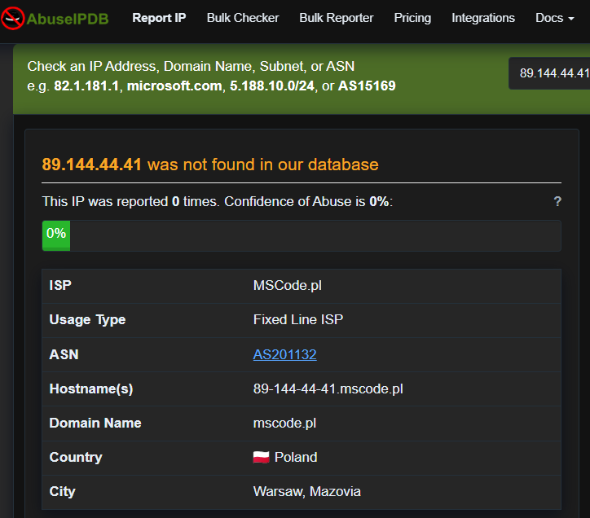Figure4 : image showing status of IP address 89.144.44.41
Even though the IP address was not reported as malicious at Virus total,AbuseipDB, and AlienVault at the time of this investigation, there is a discrepancy in location across this threat detection platforms. AbuseipDB reported that the IP originated from Poland, AlienVault reported that IP originated from Germany while the email claimed that email came from Russia.

Claim
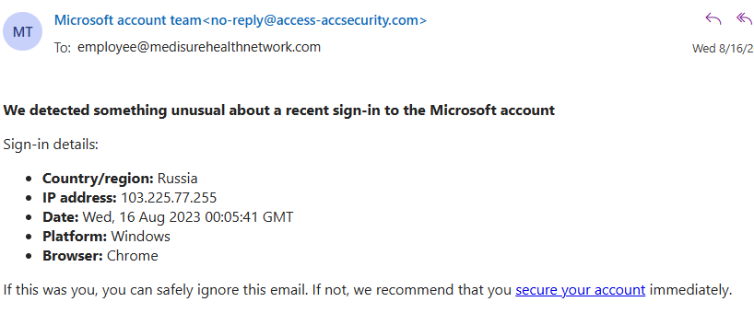Figure5.0 : Image showingFigure5.1 : Image showing body of the suspicious email received.
Another IP address (103.225.77.255) was reported in the mail, the IP was claimed to have originated from Russia

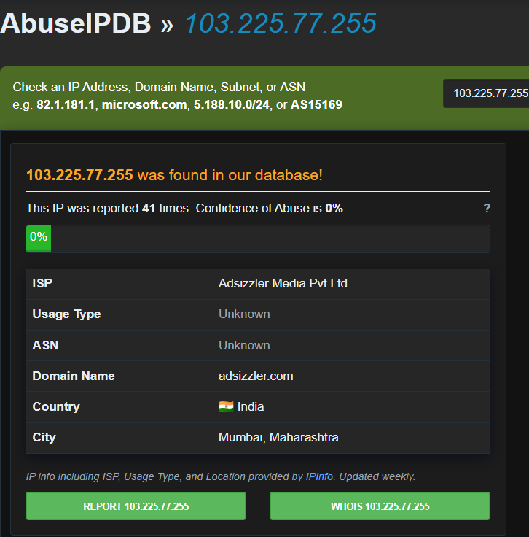Figure 5.1 : image showing status of IP address 103.225.77.255
The IP was ran through AbuseIPDB and the result shown that IP was report 41 times. Even though the email claimed that the IP originated from Russia, AbuseIPDB confirmed that IP was from India
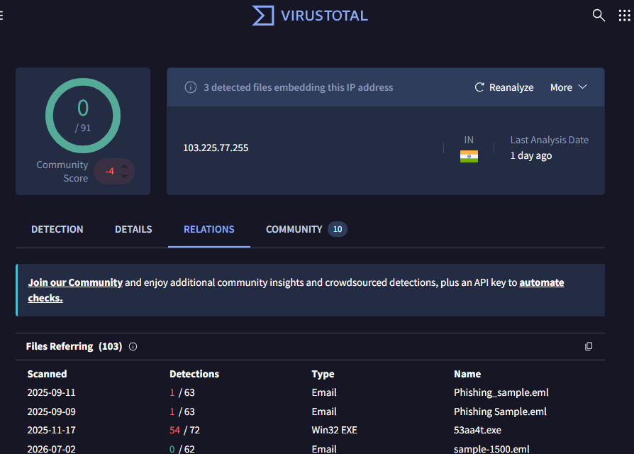
Figure 5.2: image showing status of IP 103.225.77.255 shown in the mail.

The output from VirusTotal shows that there are 3 embedding files in this IP address, this is very critical as these files could be unloaded into the organisations system if link is visited

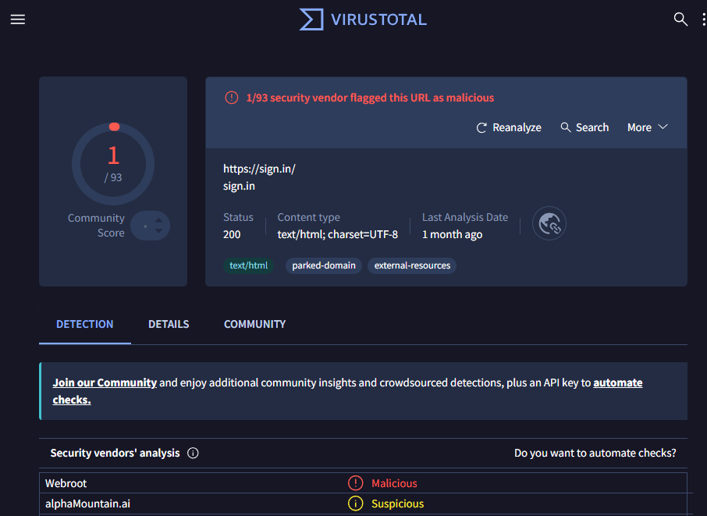Figure5.3 : images showing phishing link embedded in mail and result of phishing link analysis.
When i hovered the mouse on the link “secure your account” it redirects to https://sign.in/.
As shown in figure5.3, this link had once been reported at VirusTotal:as malicious.

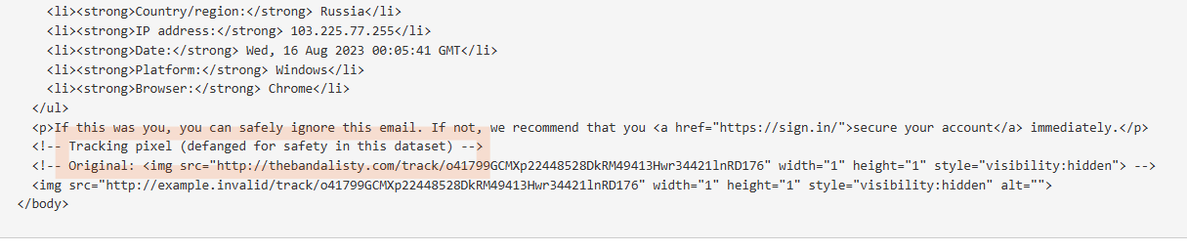
Ffigure6.0 : MXToolbox showing tracking pixel source to be thebandalisty.com
/sign.in/
./sign.in/
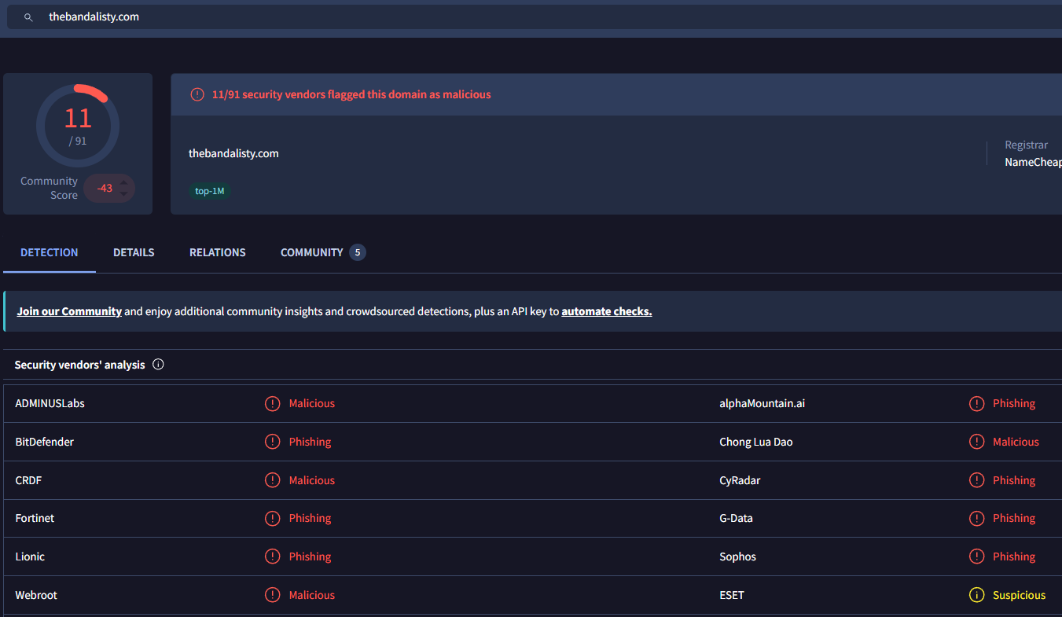Figure6.1: image of VirusTotal flagging the pixel source( thebandalisty.com) as malicious
VirusTotal reported that 11 vendors has flagged this domain as either phishing or malicious. This is a major cause for concern and more reason to treat this threat as critical.

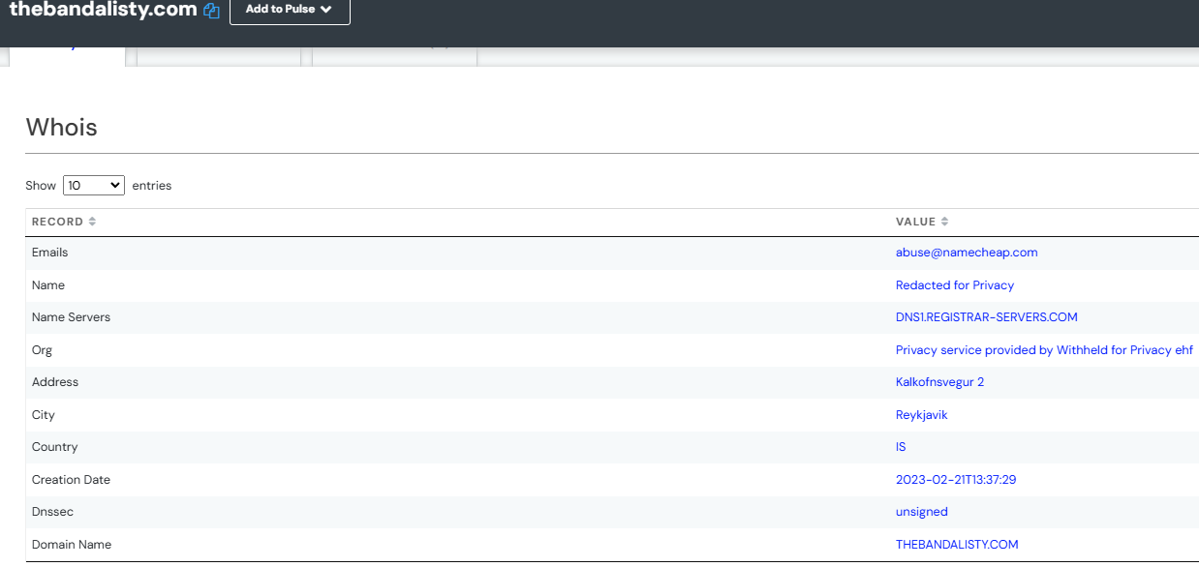Figure6.2 : image from AlienVault showing details about the domain thebandalisty.com
AlienVault reported that the domain resides in the Capital City of Iceland (Reykjavik), it also showed that Dnssec is unsigned. It’s shown that 31 passive DNS and 41 URLs are related to this domain.

Log Findings using Splunk:
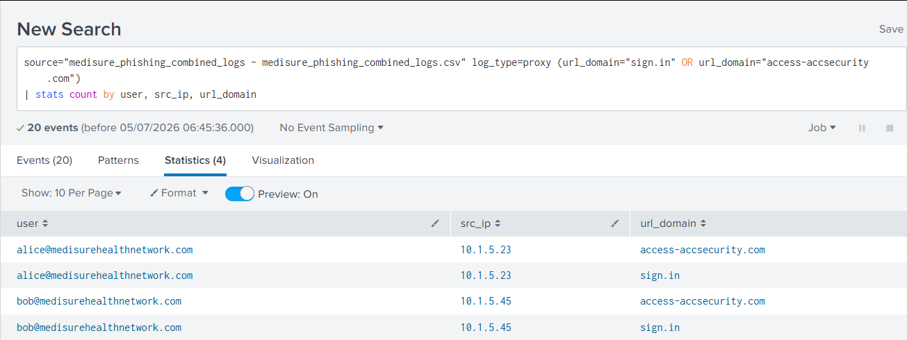
Figure 7: image showing users who visited the website
The result of the log ingested into Splunk shows that two user( Bob and Alice) already visited the website,
Visiting the website ‘sign.in’ implies that credentials has been submitted, and this calls for immediate action.

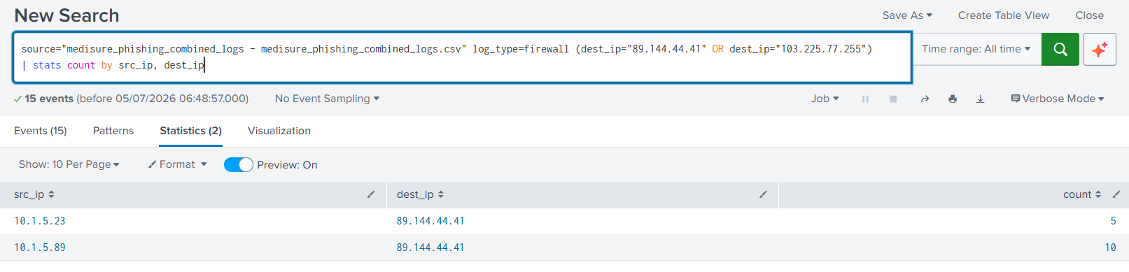Figure8 : image showing firewall log.
The result above from firewall reconfirmed that Alice and Bob interacted with the malicious link multiple times, this a call for concern.
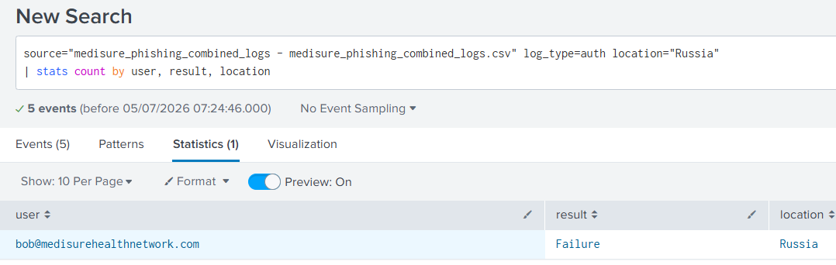Figure9 : image showing the user that connected to the attacker infrastructure.
The output shows that Bob’s system has been compromised, as the attacker is already trying to login from Russia using Bob’s account.
Bob’s computer needs to be quarantined immediately.

